EE5175-Assignment-1

Winston Doss
EE23E008

REPORT

The matplotlib.image package is used to solve all the problems in this assignment.
Question 1:
In this problem, a source to target transform gave satisfactory result.
The translation operation is performed using nested loops. For each pixel in the source matrix, the code calculates the corresponding position in the translated image (target) by adding predefined translation values (3.75 along the x-axis and 4.3 along the y-axis). These values are then converted to integers using np.floor() to obtain the nearest integer coordinates for placing the pixel in the target matrix.
Results:
Source image Target Image

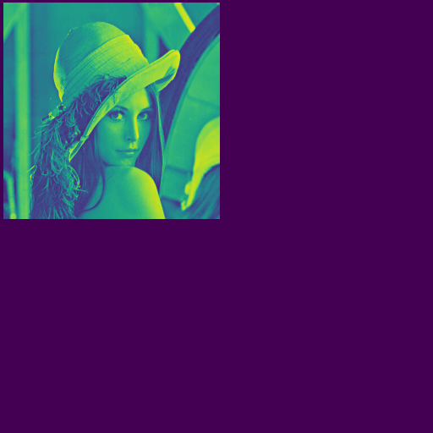

Observations:
The translation is very small when compared to size of the image. But can be observed.
If translated in the opposite direction the image would go out of bounds, which has not been accounted for in the code.
Source-target transformation seems to be enough for translation.

Question 2:
The image data from the input matrix is copied to the source matrix. This is achieved by iterating over a subset of the image matrix and assigning values to corresponding positions in the source matrix. The subset is chosen to ensure that the entire rotated image fits within the source matrix.
The image is brought to the center.
The rotation operation is performed using nested loops. For each pixel in the subset of the source matrix, the code calculates the corresponding position in the rotated image (target) using rotation formulas based on the given angle (theta). These formulas involve trigonometric functions (np.cos() and np.sin()) to determine the new coordinates after rotation.

Results:
Source image: Target image:
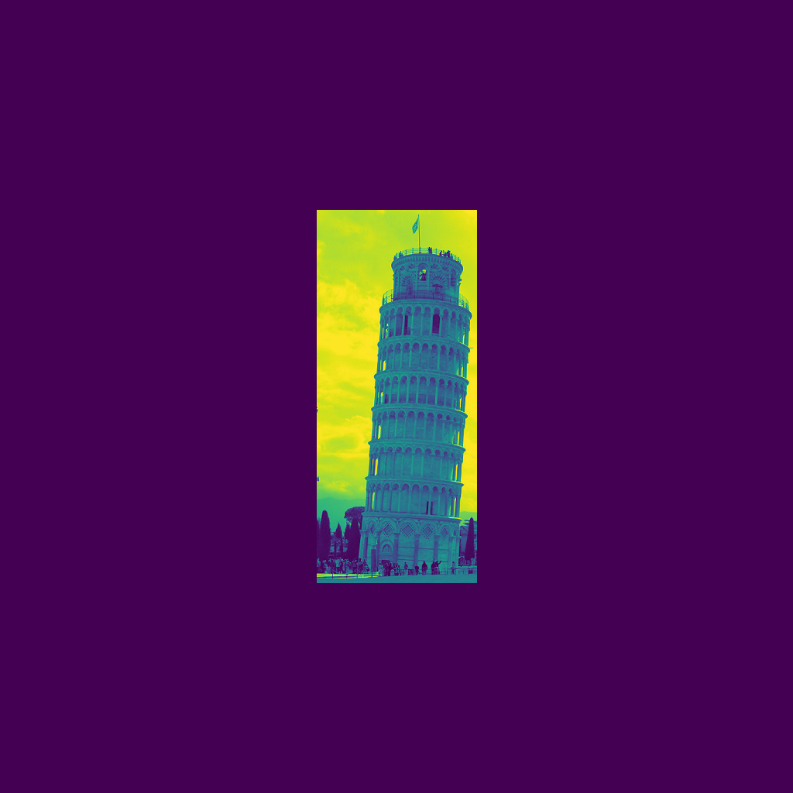
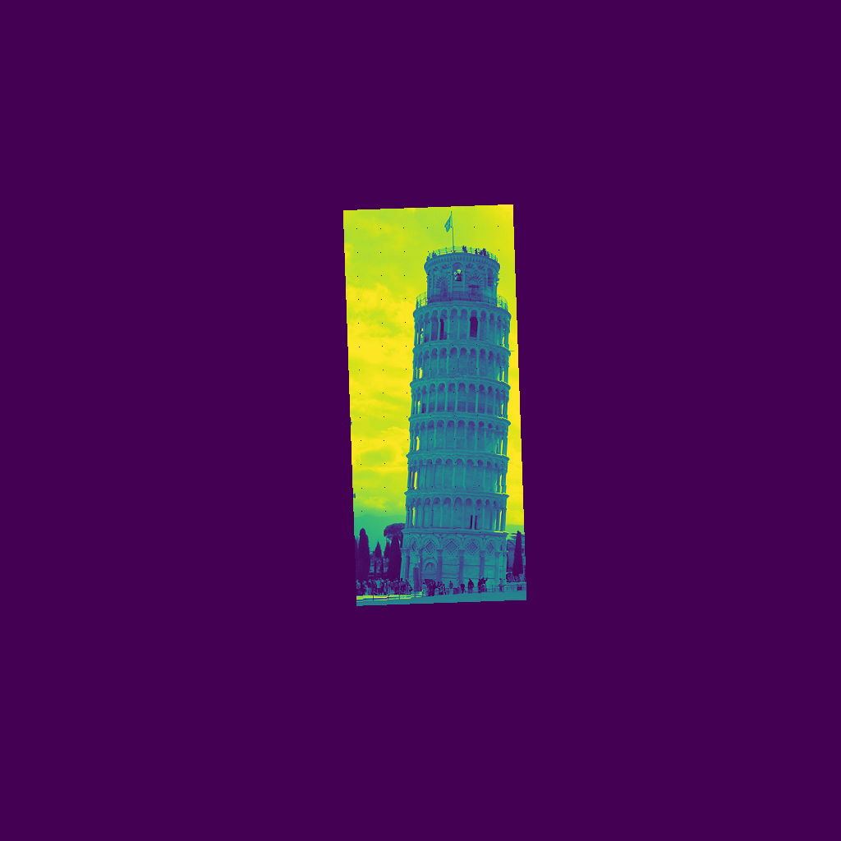

Observations:
Source to taget transformation is performed and satisfactory results are obtained. But the edges are little bit jagged. Could have been fixed with bilinear interpolation.
Question 3:
Two empty matrices, source and target, of size 1024x1024 and 512x512 respectively are created. The larger size is chosen to accommodate extra space for scaling.
Here we are performing target to source transformation.
The scaling operation is performed using nested loops. For each pixel in the target matrix, the code calculates the corresponding position in the original image (source) using scaling formulas based on the scaling factors (0.8 along the x-axis and 1.3 along the y-axis). These formulas involve simple division of coordinates by the scaling factors.
To handle fractional coordinates resulting from scaling, the code implements bilinear interpolation. This interpolation method considers the weighted average of the nearest four pixels in the original image to determine the pixel value in the scaled image.

Results:
Source image Target image

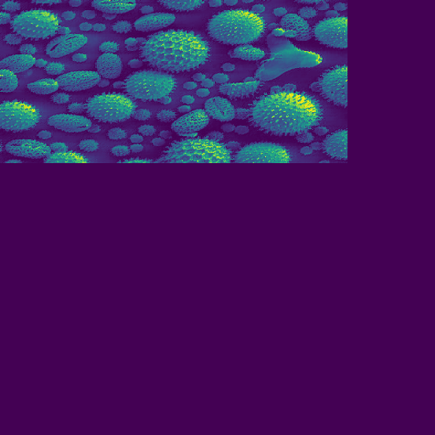

Observations:
We require a bigger canvas always when the image is made bigger. So target should be a bigger matrix.

